Sudeep Kulkarni  
Mohit Gupta  
Rajdeep Kaur  
Ira Tiwari

BIBLIOGRAPHY

USER MANUAL

**Contents**

1. Introduction……………………………………………………………………………………………….3
   1. Scope and Purpose of the application…………………………………………………..3
   2. Scope and Purpose of the user manual…………………………………………………3
2. Search for Authors……………………………………………………………………………………..3
   1. Search by Research paper title……………………………………………………………..3
   2. Advanced search panel…………………………………………………………………………6
      1. Search by position held……………………………………………………………….6
      2. Search by author name……………………………………………………………….9
      3. Search by year of Publication…………………………………………………….10
      4. Search by name of conference…………………………………………………..13
      5. Search by conference acronym………………………………………………….14
      6. New search………………………………………………………………………………..14
3. Filter results……………………………………………………………………………………………..14
   1. Apply a filter……………………………………………………………………………………….14
   2. Remove the filter………………………………………………………………………………..15
4. The Back button……………………………………………………………………………………….16
5. The Return to results button…………………………………………………………………….17

**1 Introduction**

* 1. **Scope and Purpose of the Application**

The objective of the Bibliography software is to help Program Committee Chairs and Associate Editors identify candidates for conference and journal committees. The application provides the user with a list of authors based on various factors such as topics of research papers, number of research papers published previously, conferences they were part of, etc. It also provides the user the ability to filter results based on the criteria specified.

The purpose of this user guide is to provide instructions on how the application would be used, details of each panel displayed and the search and filter functionalities. It is assumed that the user is aware of conferences, journals, publications and authors. It is also assumed that the user has the software installed on their system using the installation guide.

* 1. **Scope and Purpose of the user manual**

The primary function of the application is to search for and display a list of authors. Authors can be displayed based on the title of their paper, the year of publication, position held previously, author name, conference name and acronym. The typical sequence for using the application would be:

1. The main search page where the user can search by the research paper title
2. Or the user can go on to the advanced search page to search by any of the options as follows:
3. Previous position held
4. Author name
5. Year of publication
6. Conference name
7. Conference acronym
8. **Search for authors**
   1. **Search by research paper title**

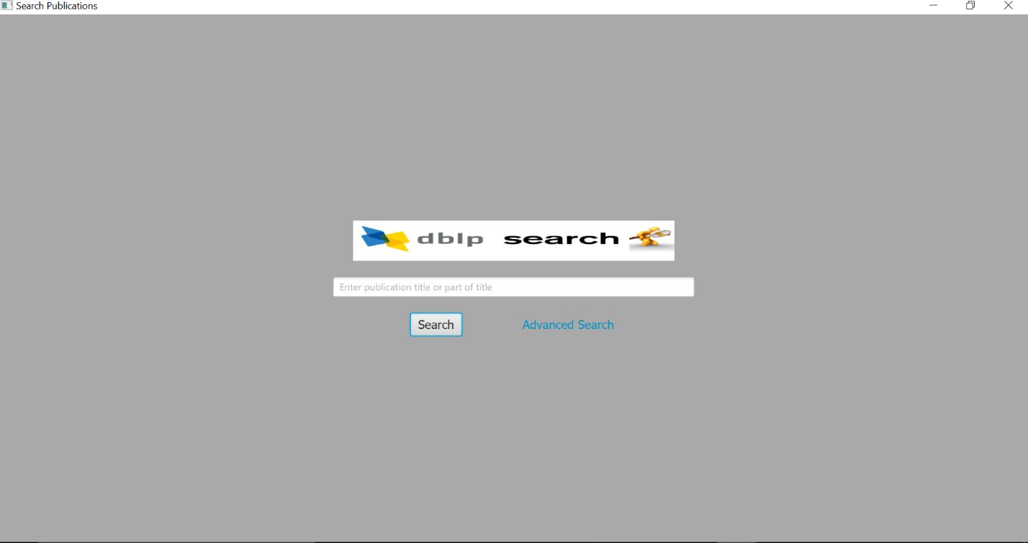

The main panel of the application has been displayed as above.

On launching the application, the user would get this page and can then enter the title or part of the publication title as shown below.

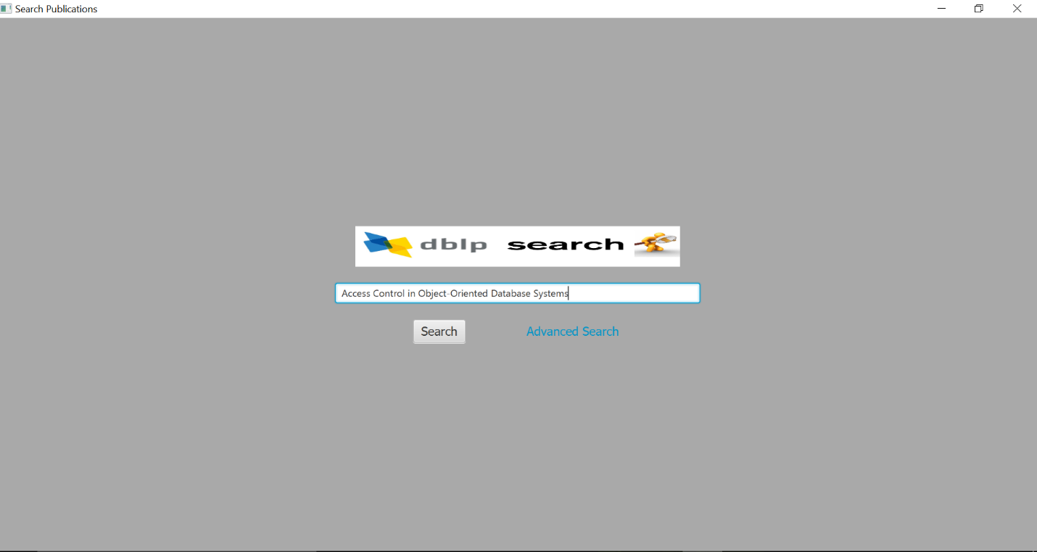

Clicking on the search button will display author details, as shown below.

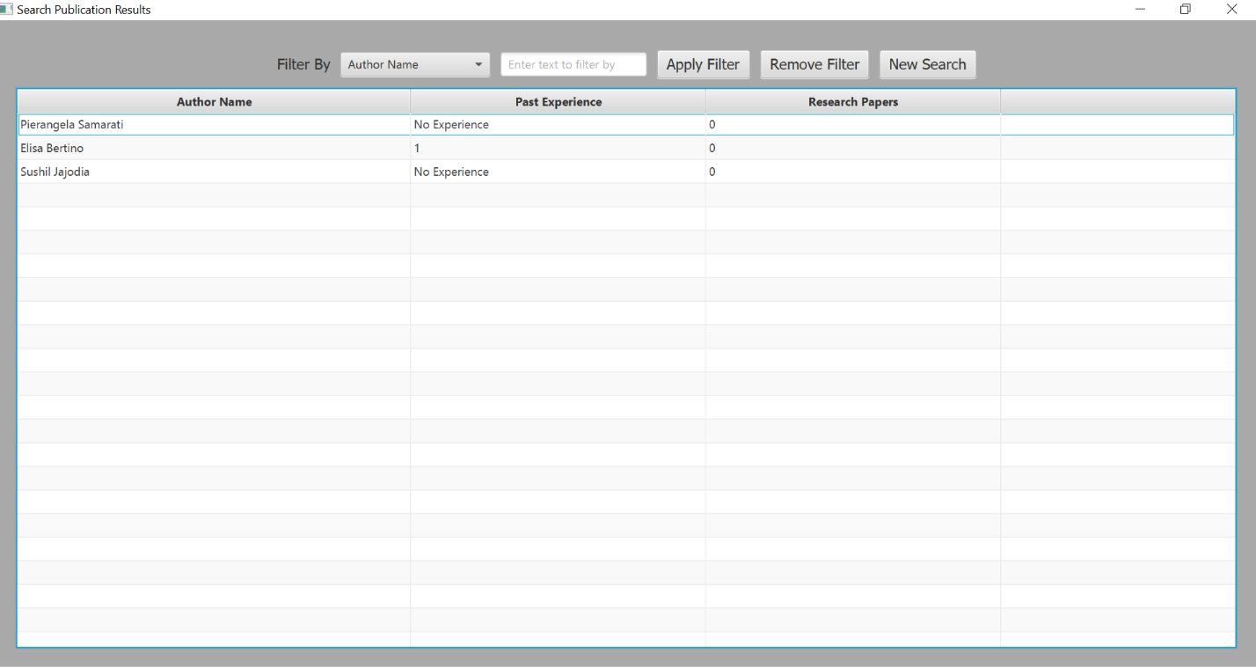

Double clicking on any of the authors will bring up an author details page. This page lists the author’s publications.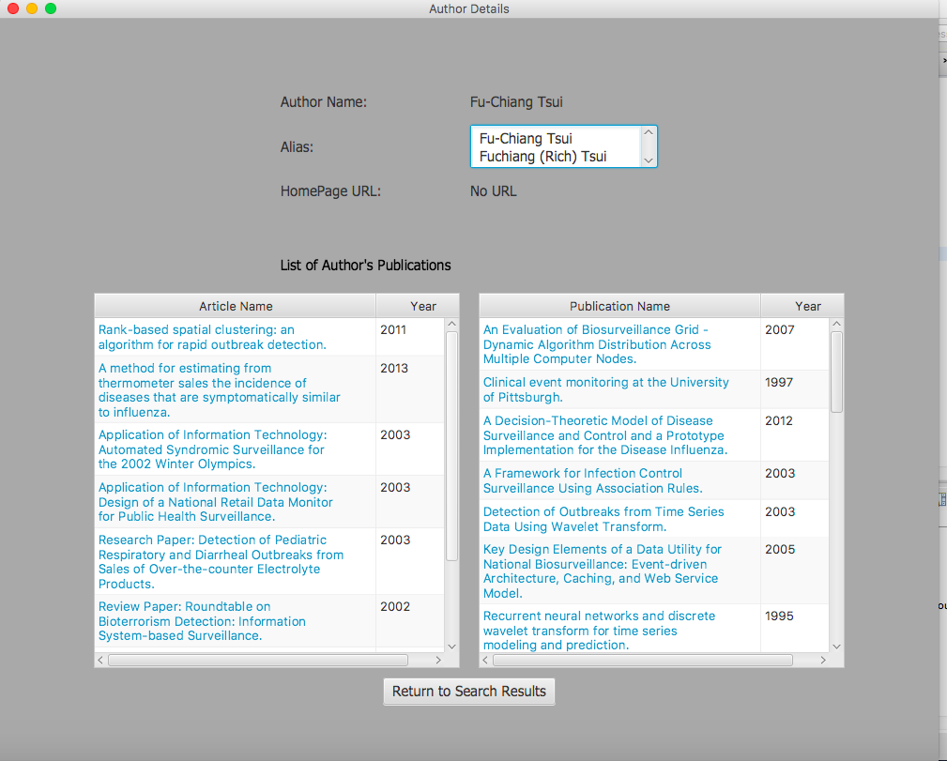

* 1. **Advanced search panel**
     1. **Search by position held**

The user can also click on the advanced search button on the homepage, which shows a new panel as shown below:

The user can look up authors by selecting positions they held previously as part of conferences or journal reviewers.

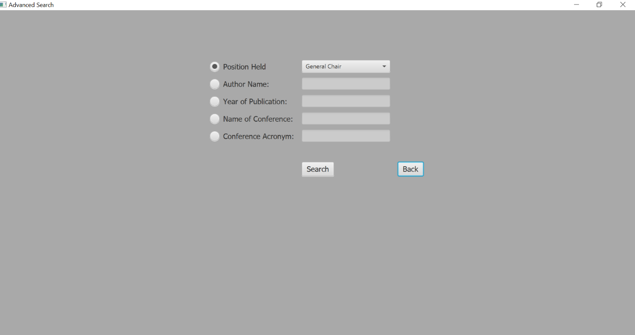

Various positions held have been shown in the dropdown, which can be chosen as needed.

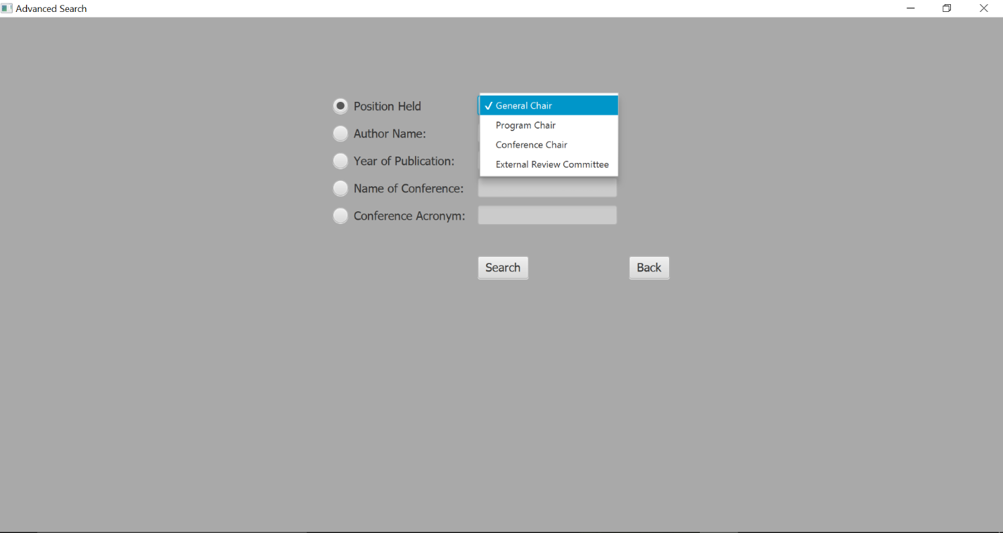

As an example, General chair has been chosen here, and clicking the search button would then bring up the next panel as follows.

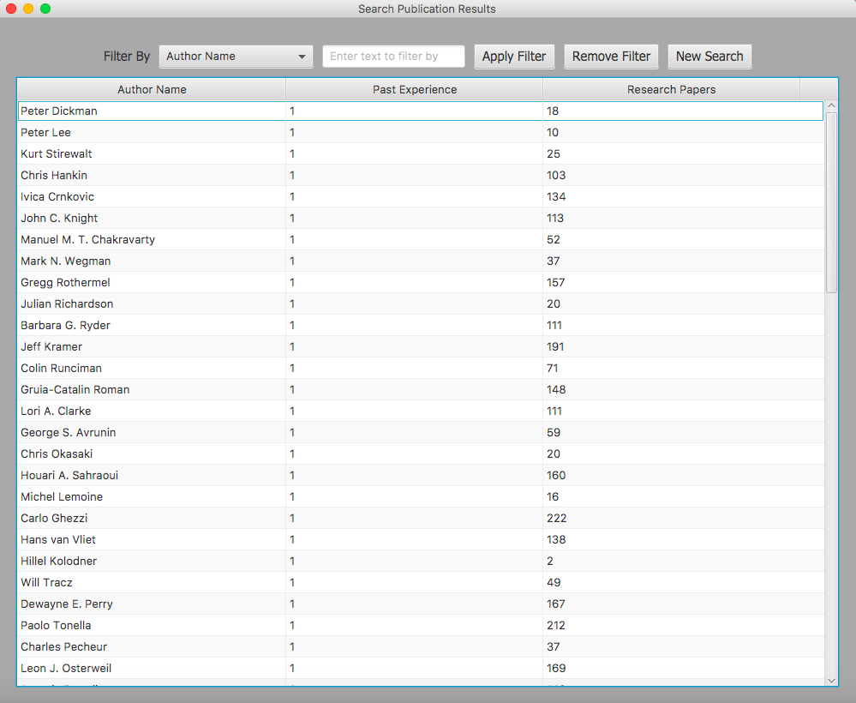

* + 1. **Search by author name**

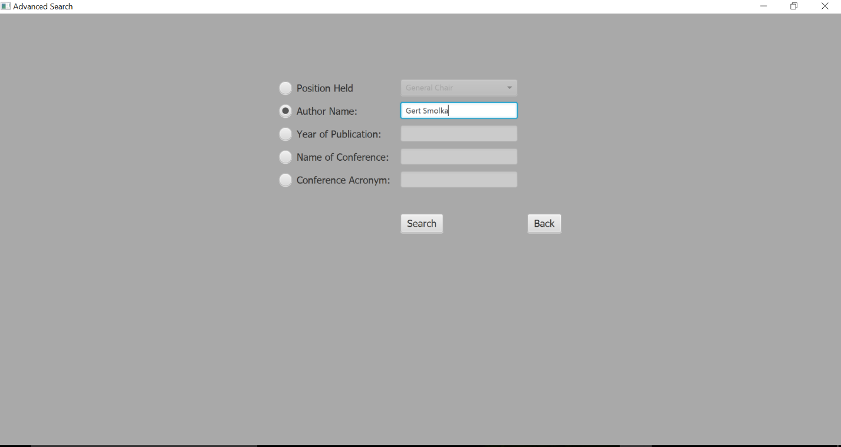

The user can enter the name of the author as illustrated above, which would show the next panel as displayed below.

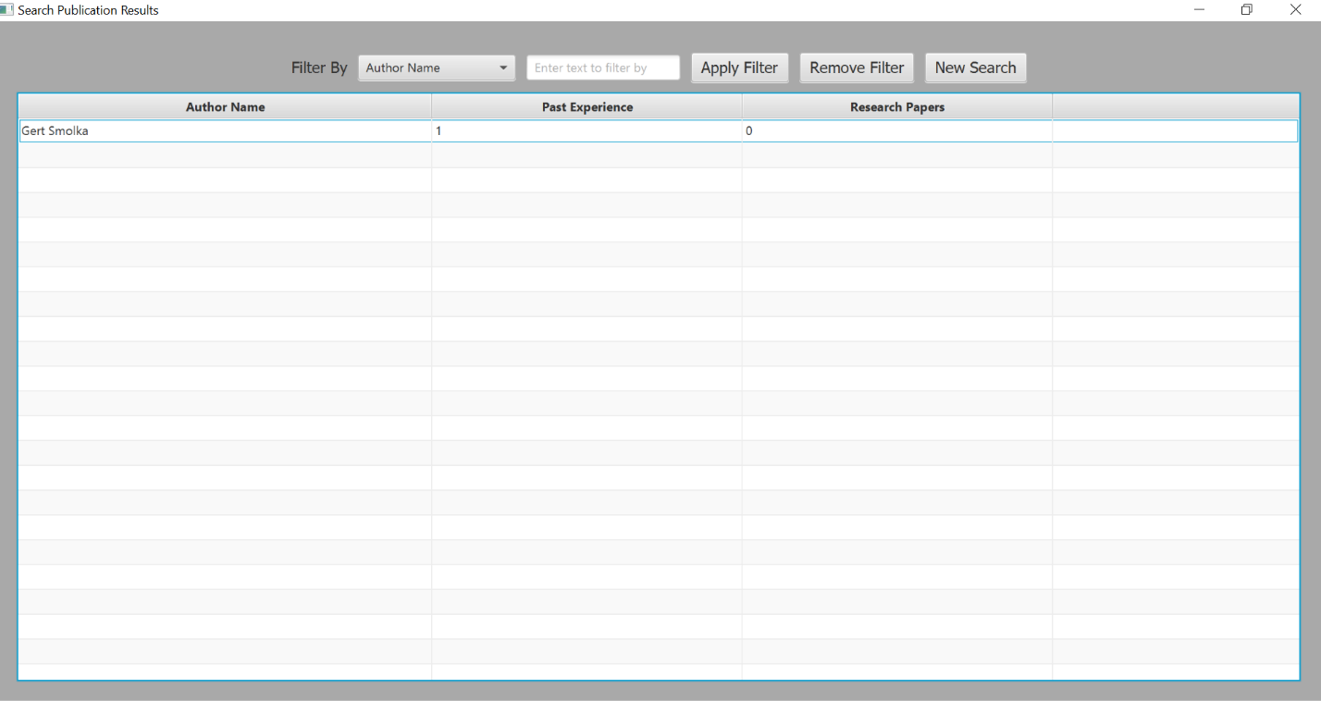

* + 1. **Search by year of publication**

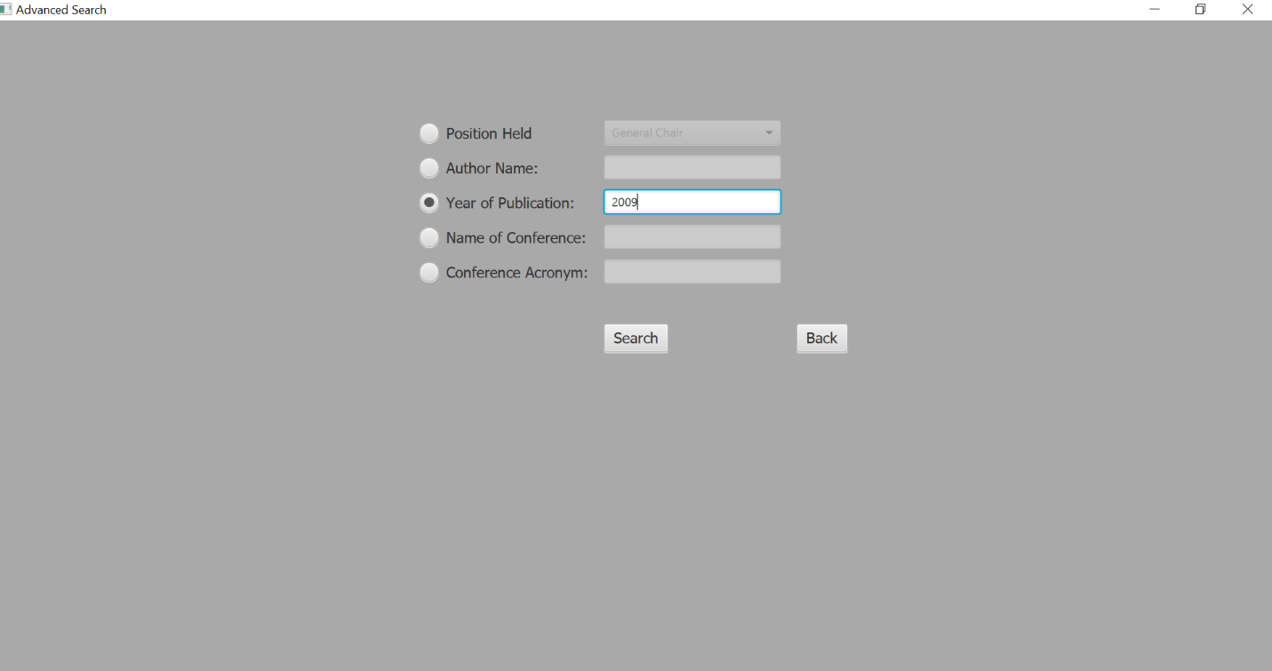

Another feature of advanced search is the search by year of publication. The user enters the year of publication which would display the next panel as shown.

A list of authors based on the years in which they made a publication comes up, as seen below.

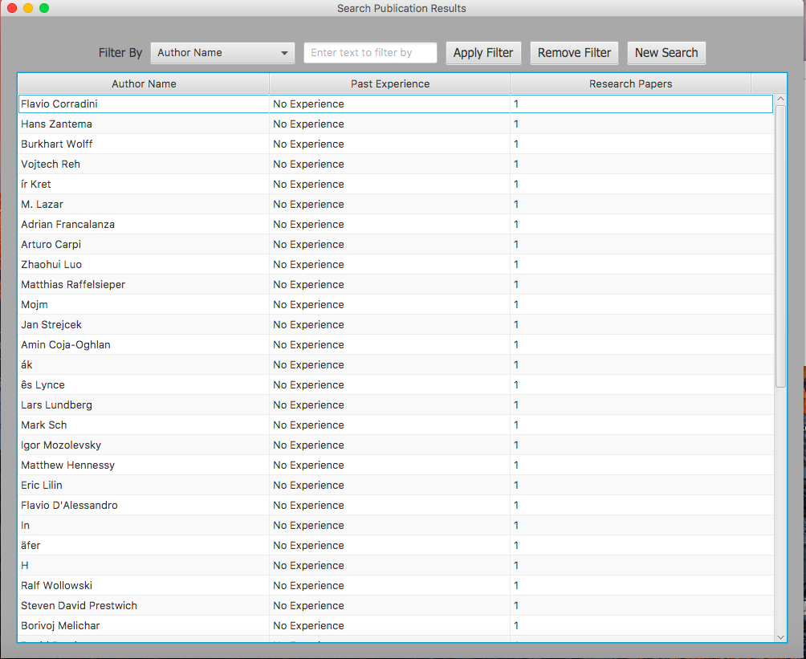

* + 1. **Search by name of conference**

The user can also lookup authors by the conference they participated in.

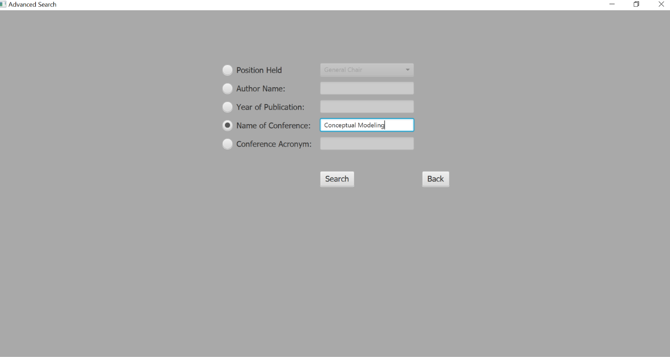

The above search shows the following results.

* + 1. **Search by conference acronym**

The following panel shows the panel for searching for authors by the conference they participated in, but this is specified by the conference acronym.

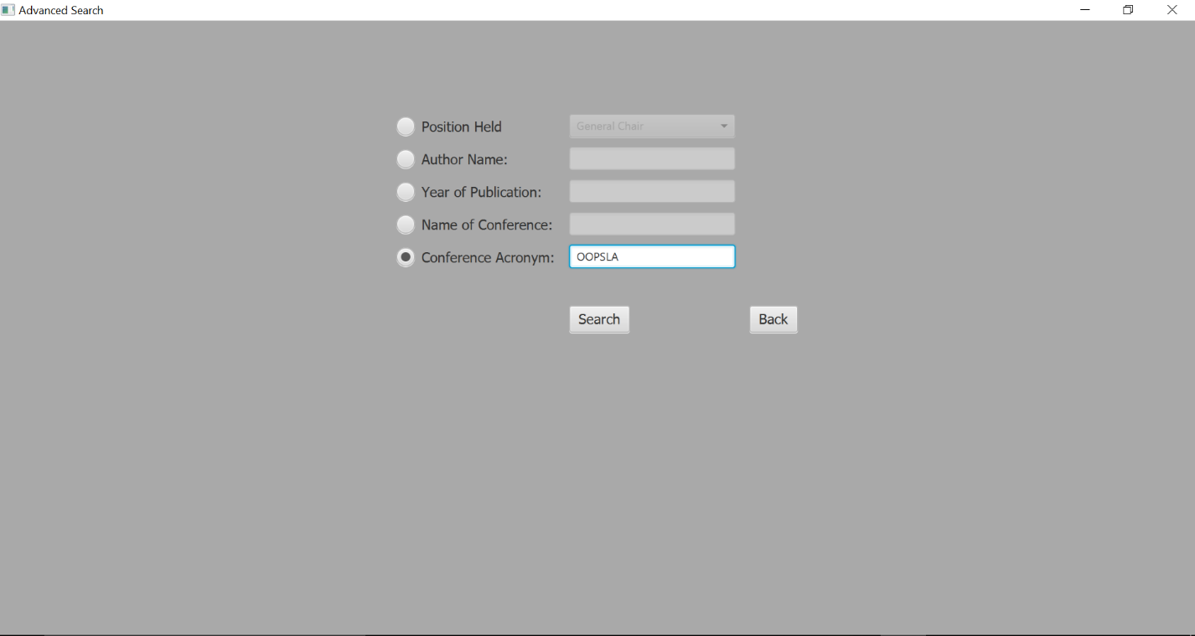

The results panel has been displayed as follows.

* + 1. **New Search**

If the user is on the panel that displays a list of authors, they can go back to the homepage of the application by clicking on the New Search page.



1. **Filter results**
   1. **Apply a filter**

From the list of authors obtained, the user can also apply filters as shown below:

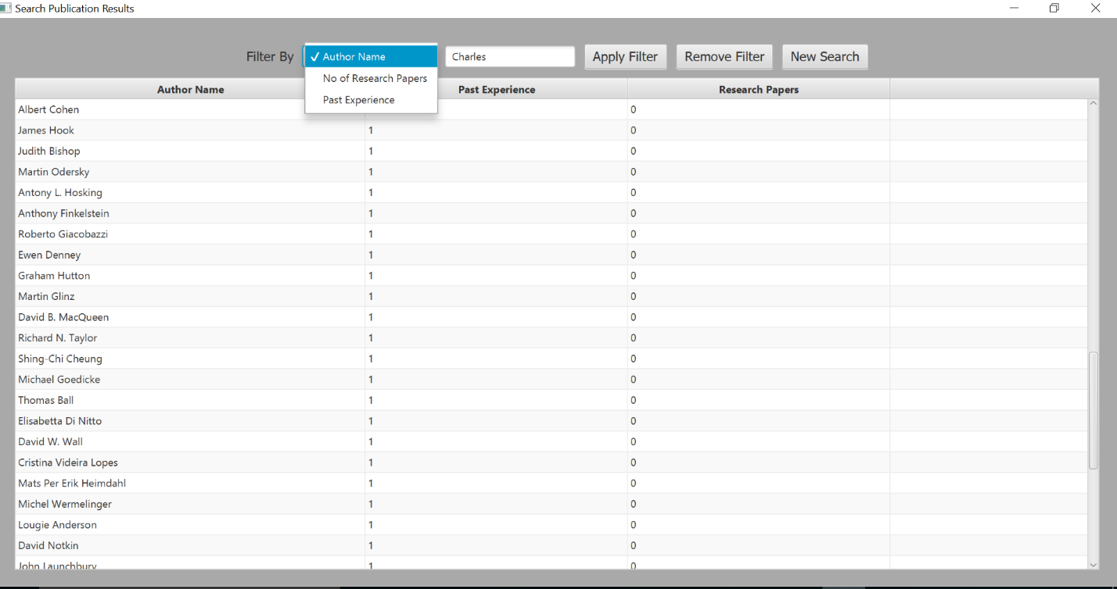

In this example, the author name filter has been selected. The name is entered in the text box.

The filtered results have been shown below.

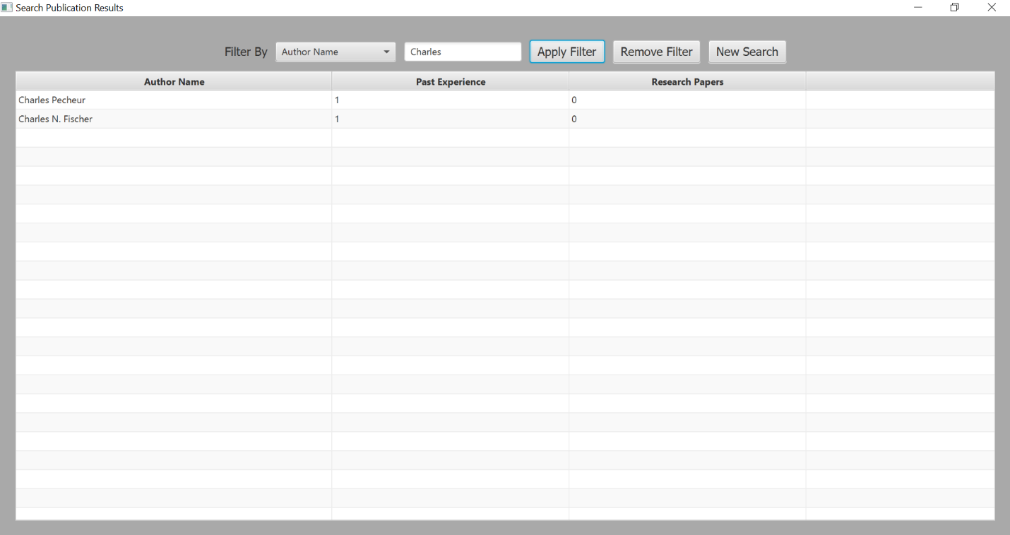

* 1. **Remove a filter**

By clicking on the remove filter button, the original results are displayed again.

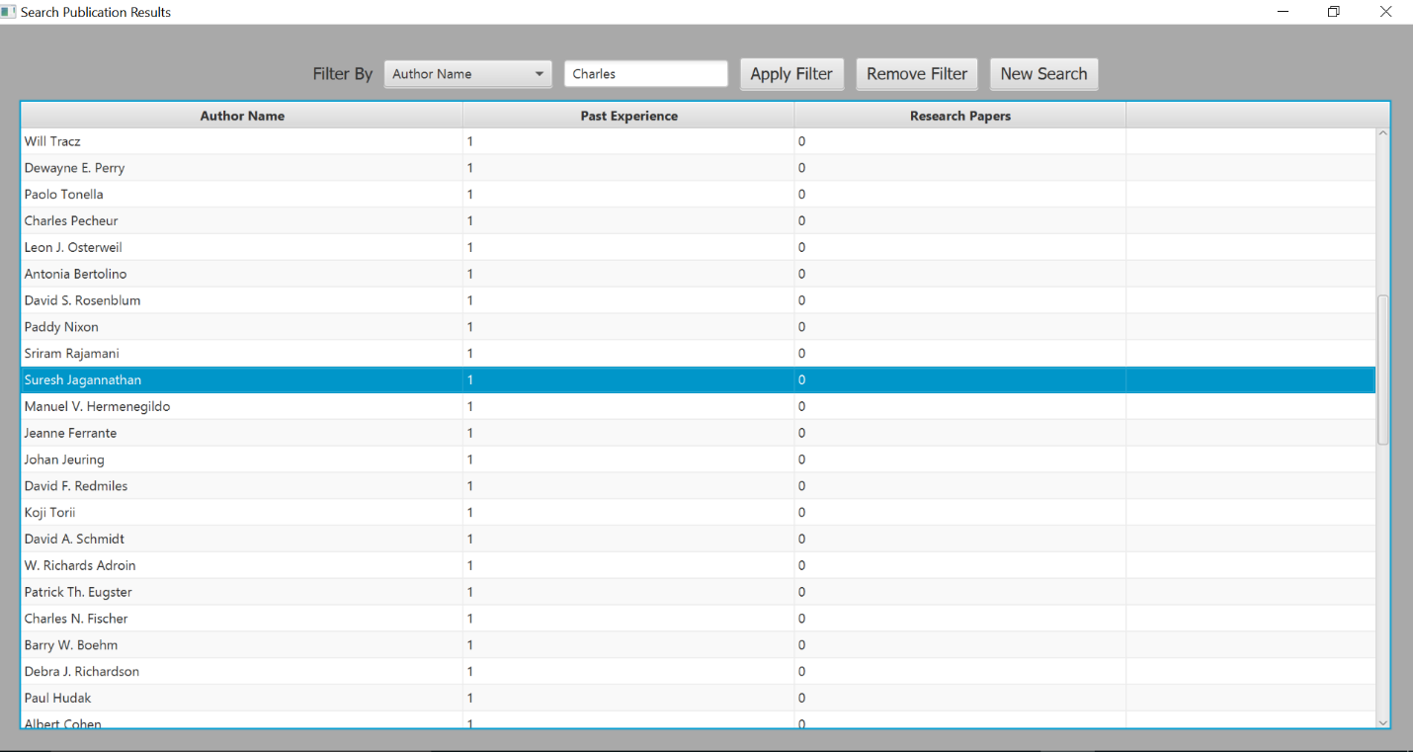

1. **The back button**

The user can go back to the home page from the advanced search page using the back button.

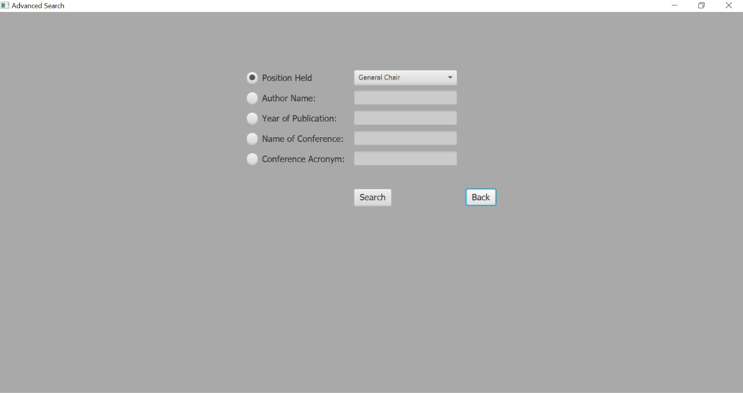

1. **The Return to Search results button**

From the author details page, clicking on the return to search results button will take the user back to the list of authors returned.



From the above panel to the list of authors page.

